Band Sponsorship Form

On October 27, 2025, the William Byrd High School Marching Terriers will host our 28th annual regional marching band competition:
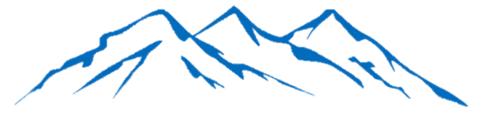

The Blue Ridge Festival of Bands

The Blue Ridge Festival of Bands invites individuals and businesses to invest in our student musicians by becoming event sponsors. Choose from various levels to showcase your support, gain visibility, and help us host an incredible day of music. A complete listing of our sponsorship packages is included on the back of this form.

If you are interested in sponsoring the band or donating to the music program, please provide the following information:
Company/Individual Name:
Address:
City, State, Zip:
Phone / Email:

Sponsorship Level:
Checks payable to WBHS BAND
may be mailed to:

WBHS Band Boosters
William Byrd High School
2902 East Washington Ave
Vinton VA 24179
☐ Donation to the Band | $
☐ Bronze Partner | $ | 150
☐ Silver Partner | $ | 300
☐ Gold Partner | $ | 500
☐ Platinum Partner | $ | 750
☐ Equipment Partner | $ | 1000
☐ Director’s Partner | $ | 2500
Total Payment | $

Sponsorship Package Information:
Donation – All donations to WBHS Marching Band will receive recognition in the event program.
Bronze Partner - $150
Half page ad in the competition program – please submit your ad & business logo.
Silver Partner - $300
Half page ad in the competition program (please submit your ad & business log), and announcements during the competition day.
Gold Partner - $500
Full page ad, announcements during the competition, and logo on the WBHS Marching Band Facebook page – please submit full page ad & business logo.
Platinum Partner - $750
Logo on cover of competition program, full page ad in program, business announced several times during competition, and logo on the WBHS Marching Band Facebook page – please submit your ad & business logo.
Equipment Partner -$1,000
Logo on cover of competition program, full page ad in program, business announced several times during the day, ad included on the WBHS Marching Band Facebook page, company-provided banner on spectator side of stadium fence – please submit your ad, business logo, and your banner.
Director’s Partner -$2,500
Full back cover ad, business announced several times during competition, complimentary tickets to the show, company-provided banner on spectator side of stadium fence, ad included on the WBHS Marching Band Facebook page – please submit your ad, business logo, and your banner.

